MATURITY OF CLOUD APPLICATION INTEROPERABILITY FRAMEWORKS FOR SMALL TO MEDIUM ENTERPRISES

John Warde

A dissertation submitted in partial fulfilment of the requirements of Dublin Institute of Technology for the degree of
M.Sc. in Computing (Advanced Software Development)

March 2015

I certify that this dissertation which I now submit for examination for the award of MSc in Computing (Advanced Software Development), is entirely my own work and has not been taken from the work of others save and to the extent that such work has been cited and acknowledged within the test of my work.

This dissertation was prepared according to the regulations for postgraduate study of the Dublin Institute of Technology and has not been submitted in whole or part for an award in any other Institute or University.

The work reported on in this dissertation conforms to the principles and requirements of the Institute’s guidelines for ethics in research.

Signed: _________________________________

Date: DD Month Year

- ABSTRACT

AAAA
(approx. 250-300 words)

Key words: list 5 to 8 words

ACKNOWLEDGEMENTS

I would like to express my sincere thanks ……….

(thank all the people how have assisted you in completing your dissertation. Start with your supervisor, all DIT staff that may have helped, other people can include family and friends, industrial and academic staff from other institution, etc.)

TABLE OF CONTENTS

Contents
1 ABSTRACT ii
TABLE OF FIGURES vii
1. Introduction 1
1.1 Background 1
1.2 Intellectual Challenge 3
1.3 Aims and Objectives 3
1.4 Research Methodology 4
1.5 Resources 5
1.6 Research Scope and Limitations 5
1.7 Dissertation Roadmap 6
2 Cloud Computing Background 8
2.1 Introduction 8
2.2 What is Cloud Computing? 8
2.3 Characteristics of Cloud Computing 9
2.3.1 On-demand self-service 9
2.3.2 Broad network access 11
2.3.3 Resource pooling 11
2.3.4 Rapid elasticity 12
2.3.5 Measured service 13
2.4 Virtualisation 14
2.5 Desired State Configuration 17
3 Cloud Interoperability Review 20
3.1 Introduction 20
3.2 Cloud Application Interoperability Research 21
4 Design 24
4.1 Introduction 24
4.2 Reference Applications 24
4.3 Infrastructure Considerations for the various Service Providers 27
4.4 Telemetry Measurements 27
4.5 Measurement Harness for Interoperability Frameworks 27
4.6 Source Code and Infrastructure Script Diversion Measurement 27
4.7 Choice of SCM 27
4.8 Measuring Diversion using Branching and Merging 27
4.9 Conclusion 27
5 Implementation 29
5.1 Introduction 29
5.2 Source Code Organisation and Management 29
5.3 Integrated Development Environment 29
5.4 Reference Applications 29
5.5 Infrastructure Scripts 29
5.6 Telemetry Implementation 29
5.7 Conclusion 29
6 Experimentation & Evaluation 30
6.1 Introduction 30
6.2 Experimentation 30
6.3 Evaluation 31
6.4 Research Question Evaluation 31
6.5 Interoperability Frameworks Evaluation 31
6.6 Existing Documentation Evaluation 31
6.7 Conclusion 31
6.7.1 Factors in Choosing an Interoperability Framework 32
6.7.2 Software Engineer/Architect Competence 32
6.7.3 Decision Factors to Migrate an Application/Component 32
7 Conclusions and Future Work 33
7.1 Introduction 33
7.2 Research Definition & Research Overview 33
7.3 Contributions to the Body of Knowledge 33
7.4 Experimentation, Evaluation and Limitation 33
7.5 Future Work & Research 33
7.6 Conclusion 33
BIBLIOGRAPHY 36
Appendix A: Cloud Interoperability Software Development Kits 39
Appendix B: Source Code Management Tools 40
Appendix C: Telemetry Tools 41

TABLE OF FIGURES
Figure 1 Java code to start an AWS EC2 compute instance 9
Figure 2 Starting an EC2 instance using CLI 10
Figure 3 Launching an AWS Instance 10
Figure 4 Under and Over provisioning 12
Figure 5 Auto Scaling 13
Figure 6 Native or bare metal hypervisor 15
Figure 7 Hosted hypervisor 15
Figure 8 Simple Web Server Setup Using Chef 18
Figure 9 Service-Oriented Cloud Computing Architecture 21
Figure 10 Reference Intercloud Topology 23
Figure 11 Design for a scalable web application 25
Figure 12 Experiment Process 26
Figure 13 Experiment Process 30

TABLE OF TABLES
Table 1 Sample Charge card for General Purpose Compute Instance 14
Table 2 Hypervisor types and makes 16
Table 3 Summary of multi-cloud framework types 23

Introduction

Organisations in all economies rely hugely on ICT to achieve success. The development of complex, innovative software solutions is a key challenge. Computing professionals with the advanced skills are needed to design and build this software that will be central to helping organisations build solutions to allow them to compete in the global digital economy. ICT professionals are now working on large scale projects in the cloud which requires deep technical expertise in software design and development plus the ability to analyse problems, data and information used in solving these large scale problem sets.

This research evaluates the maturity of multi-cloud frameworks for use in Small to Medium Enterprises to build scalable applications in the cloud. Multi-Cloud frameworks are software used to enable Cloud Application Interoperability between heterogeneous cloud service providers (CSP). They are built using advanced software development techniques, such as design patterns, to adapt and hide the differences between the run-time execution environments of cloud service providers.

Existing research suggests that SMEs will benefit from the agility of being able to run business applications in multiple cloud providers over using cloud provider native solutions, thus avoiding the vendor lock-in scenario.

In this work, a number of multi-cloud frameworks are evaluated by building a reference application for each of the frameworks and assessing the technologies on factors such as effort, performance and functionality.

  - Background
An Information Technology (I.T.) revolution is upon us, cloud computing is no longer a buzz word, it’s here to stay. Although in the “Trough of Disillusionment” according to (“Gartner’s 2014 Hype Cycle for Emerging Technologies Maps the Journey to Digital Business,” 2014), the levels of investment and spending ($566 billion dollars since 2010 (“Forecast Overview,” 2012)) suggest it’s too big to fail.

It has been driven, in part, by the demand from the recent growth of large scale social media and e-commerce sites which in turn has been driven by us the social media consumers and our increased online spending. Companies such as Google and Facebook have had to invent their own paradigms and technologies such as MapReduce (“IBM - What is MapReduce,” 2014) and Cassandra (“What is Apache Cassandra?,” n.d.) to cater for the increased demand for their services. These data hungry and mission critical applications are very scalable and require the I.T. resources behind them to be scalable too.

This in turn has influenced other, some times more traditional, enterprises in their desire to achieve similar accelerated growth and flexibility to react to changes in the marketplace, or worse risk being left behind. Big Data and business intelligence (or analytics of large amounts of market/user behavioural data) has helped companies to make better business decisions and reduce risk rather that rely solely on personal opinions (“How Big Data Can Reduce Big Risk,” 2012). A significant portion of the overall spend on cloud computing is not directly on the product (to the consumer) but rather on moving existing business support infrastructure and software into the cloud, such as Customer Relationship Management (CRM) and Human Resources (HR) systems.

The affect is cutting across disciplines, it is influencing not only the infrastructure side of businesses but also the software development, project management, and business processes, and to some extent accounting where there is less capital expenditure spend with cloud computing. TODO: [JC Comment: explain or give examples of …] Agile processes have been part of this industry for some years but it has become an essential paradigm used by software development teams that need to respond to the ever changing demand of the market and the data analytics that indicate what the business should do next. Cloud computing has made I.T. infrastructure more agile, no longer has the development team to wait weeks to months to get hardware provisioned by the I.T. department. Software development phases happens in terms of time rather than functionality, this has a direct effect on project management entities within a company. Software engineers are skilling up to keep up with these changes – learning new APIs and techniques needed to build robust and scalable applications that can span continents.

Global economies and Ireland in particular, are currently engaged in a ‘knowledge revolution’ evolving from a manufacturing to a service base fuelled by technological advances (Building Ireland’s Knowledge Economy, Report to the Interdepartmental Committee on Science Technology and Innovation, 2004). As part of its EU2020 strategy the European Union is currently progressing its Digital Agenda with the aim to find a fast road to economic recovery which puts Information and Communication Technologies (ICT) at the heart of this strategy (A Digital Agenda for Europe, Communication from the Commission to the European Parliament, the Council, the European Economic and Social Committee and the Committee of the Regions, 2010). The European Union is also funding much research and innovation, the Horizon 2020 is the largest EU programme ever with nearly €80 billion of funding available over 7 years (“What is Horizon 2020?,” n.d.), with cloud computing and ICT related research cutting across many diverse areas (“Guide to ICT-related activities in Horizon 2020,” 2013).

Utility services (such as electricity and telephone) as we know them today went through an evolution from innovation to agreed standards, to economies of scale. Innovation is still high in cloud computing, standards are only being discussed/researched. Some global enterprise organisations are tentatively working with cloud technologies to evaluate the long term benefits; however they want to avoid the vendor lock-in of the past. Interoperability will thrust this fledging industry into commoditization of services. By 2025, the expected economic impact, in the U.S., from cloud technologies is expected to be somewhere from 1.7 to 6.2 trillion dollars per year (Columbus, 2013).

  - Aims and Objectives
The aim of this research is to garner information and knowledge around the development and use of multi-cloud frameworks, to evaluate them with the view to applying these to the reference application design. The results of testing these frameworks will be used to analyse the maturity of each framework and then synthesise that knowledge to evaluate and give recommendations for use in SMEs and start-ups.

The Project Objectives are:
- Investigate the current views and research conducted to date on multi-cloud frameworks and Cloud Application Interoperability.

- Examine the current state of nominated multi-cloud frameworks.

- Develop an experiment to evaluate the nominated frameworks based on technical criteria.

- Document and evaluate the findings from the experiment.

- Based on the evaluation, suggest a set of improvements that would increase the adoption of multi-cloud frameworks in start-ups and SMEs.

- Make recommendations for future research in this area.

  - Research Methodology
The research will be carried out in the following phases:
- Perform a literature review of cloud computing and cloud application interoperability areas to assess the current status of interoperability research and to use the knowledge gained to choose the frameworks for the experimentation part of this research.
- Design and develop reference application software.
- Adapt the reference application to use the chosen frameworks.
- Assess the maturity of the frameworks by reviewing the success of the experimentation and the effort involved.
- Summarise the research, draw conclusions and recommend areas of future research.

The reference application is a scalable compute intensive application which consists of message queues for asynchronous communication between the clients requesting the computation and the processing components. The processing components will read data from block storage or a database. This type of application would be used in many SaaS (Software as a Service) applications, for example, the photo sharing site flickr.com can apply effects to photos or as a component in a web crawler which processes HTML documents to extract keywords from many web sites.

Results will explore if multi-cloud interoperability is on its way to achieving benefits for SMEs, and will examine if the frameworks reviewed are ready for production applications.

  - Resources

Technical Resources Required:
• Laptop with internet access
• Access to open source multi-cloud frameworks
• Java SE SDK and Jave EE SDK
• Development IDE such as Eclipse
• Cloud Service Providers supporting the multi-cloud frameworks
• GitHub for source control
• Microsoft Word / Microsoft Excel / Microsoft Project / Microsoft PowerPoint
• External hard disk and on-line storage for backup

Non-Technical Resources Required
• Library Access
• DIT Shibboleth Login for access to papers

  - Research Scope and Limitations
This research will appraise the maturity of a number software frameworks/APIs that enable software developers to build applications in the cloud where that application can be moved from one cloud supplier to another seamlessly or at a very minimum of configuration change and cost. Some of these frameworks also allow individual components of the application to execute on two or more cloud service providers where those components can communicate across CSPs.

As the title suggests this research is aimed or evaluated from the perspective of an SME. However, Small and Medium Enterprise is a broad term and multi-cloud framework software would require software development knowledge and would generally be aimed at companies where a significant part of their business is software development or a company with a business unit which produces software. Multi-cloud frameworks could also be very useful to Internet Start-ups that intend building an on-line application and want to keep their costs low by being able to switch providers to lower costs. However, enterprises without software developers could benefit from this research, they could come to a decision to build a software team that could use a multi-cloud framework to build an on-line application to innovate in their area of business without fear of vendor lock-in and could build on their competitive edge. An example in case would be the Lotus Formula 1 racing team who has used cloud computing to reduce costs (“The Real Cloud Computing Revolution,” 2014).

Experimentation in this research will include developing a reference application of a typical scalable web application and then adapting that application to use each of the frameworks. The reference application follows a typical scalable web application where some compute intensive operation (such as applying special effects to photographs on photography website flickr.com) is required and the user interface must still remain interactive. This is achieved by using message queues to manage the compute intensive operations as efficiently as possible. As the load on the web application increases the number of web servers and (compute intensive) processors can be increased to cater for the load and maintain the interactivity of the user interface. On the client side (browser/mobile), an AJAX web page will poll the server side scripts, which in turn will use the information in the response queue (when it eventually becomes available) to retrieve the results of the compute intensive operation (such as the new image with the applied special effect).

Chapters 2 and 3 reviews existing research in cloud computing and interoperability which includes automatic Service Level Agreements negotiations via automation. However, this functionality is not tested in the reference application in the experiment except to comment on its availability after reviewing the multi-cloud framework documentation.

  - Dissertation Roadmap
This research is organised as follows. Chapter 2 presents a brief history, background and definitions on cloud computing and recent research in the area. Building on that, the 3rd chapter explores cloud application interoperability, the different types and approaches used by research teams in this area. Chapter 4 describes the design of the reference application software, the tools used to build it and the plan and process of adapting the reference application to each framework using the branching features of source code repositories. Consequently, Chapter 5 will describe how the measurement effort will be interpreted and how the experiment process will be carried out in this research. Chapter 6 documents the experiment and its results. Finally, Chapter 7 presents conclusions and possible future research.

- Cloud Computing Background

TODO: Need more relevant references.
DONE: Labels should be above tables whereas labels on tables should remain below, example ref: http://writingcenter.waldenu.edu/Documents/APA/Tables_and_Figures.pdf
  - Introduction
Cloud Computing is the availability of temporary remote computing infrastructure (such as disk storage, compute time, routers etc.) and services (such as email, message queues) which are sold on a unit basis (hourly, monthly) with no long term contract. These can be provisioned (or de-provisioned) in a matter of minutes, rather than weeks or months for on premise systems. The idea of cloud computing has been around for some time, computer scientist John McCarthy (son of an Irish immigrant) who proposed the idea of computation being delivered as a public utility, similar to the service bureaus which date back to the sixties (Arif Mohamed, 2009). In 1999, Salesforce.com launched a customer relationship management system which aligned with John McCarthy’s idea and in 2002 Amazon Web Services offered infrastructure as a service, since then the interest, investment and innovation in cloud computing has sky rocketed. Cloud computing affects and transforms current computer infrastructure and services. In just a few years, it has managed to evolve into one of the most influential IT trends, registering for a second successive year in first place in Gartner’s 2011 list of top strategic technologies (“Gartner Identifies the Top 10 Strategic Technologies for 2012,” n.d.).

  - What is Cloud Computing?
There are many different definitions of cloud computing, some research papers attempt to consolidate the different definitions (Vaquero et al., 2008). However, the National Institute of Standards and Technology (NIST) based in the USA gives a succinct definition: “Cloud computing is a model for enabling ubiquitous, convenient, on-demand network access to a shared pool of configurable computing resources (e.g., networks, servers, storage, applications, and services) that can be rapidly provisioned and released with minimal management effort or service provider interaction. This cloud model is composed of five essential characteristics, three service models, and four deployment models.” (Mell and Grance, 2011).

  - Characteristics of Cloud Computing
The NIST definition lists five characteristics of cloud computing namely, On-demand self-service; Broad network access; Resource pooling, Rapid elasticity and Measured service.
    - On-demand self-service
The cloud service provider provides mechanisms to allow customers to provision computing resources such as disk storage, server machines, databases, routers, DNS and software applications. This self-service mechanism is usually provided through 3 methods, each method allows the consumer to request, interact and decommission computing resources:
- Application Programming Interfaces (APIs): When building software applications, software developers use APIs to automate the interaction with the CSP’s computing resources. This is the most efficient of the interaction methods, requires a level of skill for usage and can have a steep learning curve. It allows full access to all the functionality that a cloud service provider exposes to consumers of their services.
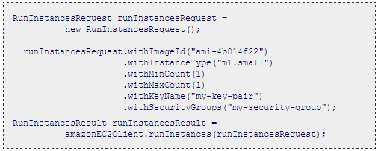
Figure 1 Java code to start an Amazon Web Services EC2 compute instance
(“Run an Amazon EC2 Instance,” n.d.)

- Command Line Interface (CLI): Generally the domain of System Administrators and infrastructure engineers, this allows users to type in commands in a console like interface and is used to quickly commission/decommission computing resources and troubleshoot problems with provisioned resources. The commands issued in the console will in turn make calls to the APIs.
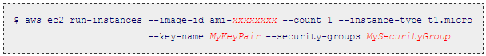
Figure 2 Starting an Amazon Web Services EC2 instance using Command Line Interface (Linux)
(“Launching an Instance,” n.d.)

- Web Based Graphical User Interface (GUI): The majority of users start here and generally after signing up on-line with a new cloud service provider you are presented with the GUI built in HTML 5 and using AJAX to allow the GUI feel more like an installed application rather than a regular web page. The GUI in turn will make use of the API and/or CLI to carry out the instructions intimated by the user actions.
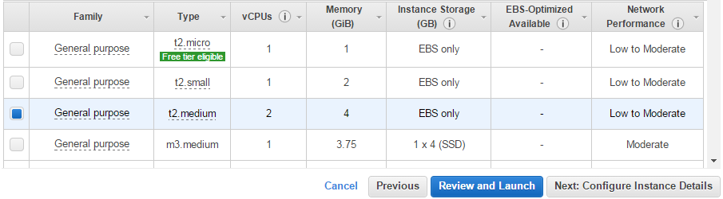
Figure 3 Launching an Amazon Web Services Instance from Amazon Web Services’ web interface
(“AWS Amazon EC2 Pricing,” n.d.)

None of the above methods require human interaction with the service, the service providers build robust interfaces, detailed on-line documentation and advisor/expert type articles to reduce the need for support phone calls and face-to-face interactions – the cloud service providers are looking for efficiency at every level so that they can pass on the savings to the consumer and stay competitive. Generally when you are first exploring a new cloud service provider you start interacting with the above interaction methods in reverse as you gain knowledge and insight into the intricacies of the provider.

    - Broad network access
Cloud service consumers are able to access the CSP provided services anywhere any time – enabled by providing access via the internet. As outlined above, CSPs provide a Web 2.0 type interface and this allows access through workstations, laptop, tablets and smartphones; some CSPs also provide a native smartphone and/or tablet application to provide a better experience on a mobile device to allow the consumer to be able to react quickly to demand or troubleshooting. With broad network access come security concerns and these can be mitigated by security certificates, virtual private networks (VPNs) and other methods.
    - Resource pooling
A big enabler of cloud computing is the concept of virtualisation. Entire Operating Systems (OS) have been virtualised within physical machines; a number of virtual machines (VMs) can exist within a single physical machine. The VMs can have different operating systems installed within them i.e. a physical Linux machine could host a Linux VM, a Windows VM and a Mac VM within it. Usually, these VMs have moderate disk space configured on the same virtual disk as the OS and then the VMs connect to a Storage Area Network (SAN) where the majority of the CSP’s customers store their data. The SAN will be a highly optimized set of hard disks or Solid State Drives (SSD) and this again is virtualised for customer disk quotas and for response times according to each customer’s service level agreement (SLA). The SLA comes into play again when virtualising CPU cycles on the physical host servers so that VMs get the correct level of CPU time there. Virtualisation enables the cloud service provider to pool its overall physical resources and get the most out of its hardware. The CSP will keep a certain level of physical computing free, ready to respond to increased customer demand and then only order new physical resources when needed to keep capital costs down. However, for any one cloud server consumer, each of their VMs could exist on any one of the thousands of physical machines within the CSPs data centre and their data could exist on various physical hard disks – this is hidden/abstracted from the consumer and they can’t tell which physical computer it resides on. Consumers are given some level of control, to comply with laws and to reduce latency to the consumer’s users, by specifying geographical locations such as Europe West and United Stated of America East Coast etc.

    - Rapid elasticity
For an on premise application where a company provision their own hardware, they attempt to plan their capital expenditure (CAPEX) of computing resources around predicted demand for their service, this can lead to over provisioning and they may losing money or they have under provisioned and they can’t meet current demand because their supplier is slow in delivering new hardware, and thus reducing customer satisfaction due to poor response times.
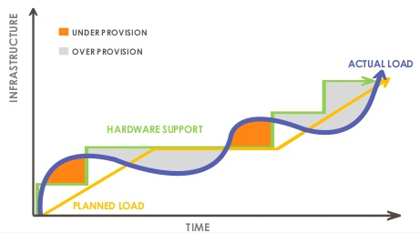
Figure 4 Under and Over provisioning of I.T. resources in relation to user demand
(IntelliGrape Software, 2013)

Through the use of APIs and automation the cloud service providers allow their customer to automatically scale up or scale down. The customer can have different levels of control: full control directly through the APIs where the customer starts up (or tears down) another compute instance (virtual machine) or load balancer, or at an indirect level where the CSPs automation controls the numbers of active instances of nodes based on an algorithm supplied by the customer (or a default by CSP). This algorithm will use system performance numbers such as average CPU usage across all VMs, average Input/Output Operations Per Second (IOPS) etc. This elasticity allows spending on IT resources to better follow demand.
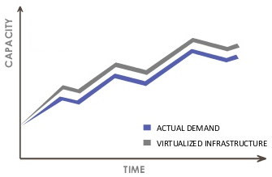
Figure 5 Auto Scaling with on demand compute resources can align closely with demand
(IntelliGrape Software, 2013)
    - Measured service
For acceptance by mainstream business, cloud computing needs to be transparent about the fees charged for their services. Everything is measured, disk space/quotas, number Input/Output operations initiated, bandwidth travelling outside the cloud service providers’ datacentres. However, unlike a utility where you might have one or two rates for one provider, cloud service providers have many different rates not only for the different type of computing resources but also for the difference sizes and processing power of those computing resources. Determining the overall costs or verifying the costs are sometimes challenging when consumers first decide to on-board to cloud computing and new businesses have started up around this too.
Table 1 Sample Charge Card for General Purpose Compute Instance on Amazon Web Services
(“AWS Amazon EC2 Pricing,” n.d.)
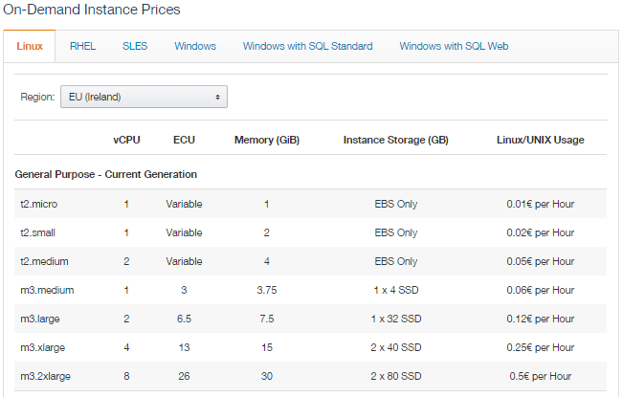

  - Virtualisation
Virtualisation is the cornerstone of cloud computing and has allowed it to flourish. It allows cloud service providers to efficiently use their hardware resources by utilising as much of the computing power of a single machine as much as possible. Cloud service providers are not the sole users of virtualisation, many companies across the globe have been creating VMs on their “on premises” hardware for many years. Virtualisation is a mature and robust technology.

Virtualisation allows multiple logical operating systems to operate on a single physical machine. This is done by creating a hardware abstraction layer; each virtual machine (VM) requests use of the hardware devices on the physical machine through this layer and the Virtual Machine Monitor (VMM), or more commonly known as a hypervisor. There are two types of hypervisors:
- Native or bare metal: the hypervisor sits directly on top of hardware and above this multiple Virtual Machines/Operating Systems and then the applications that run within those VMs.
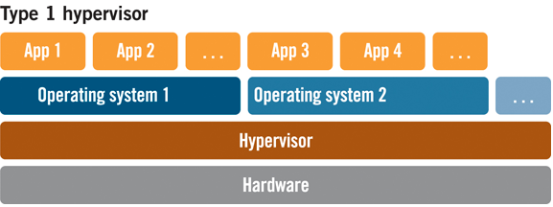
Figure 6 Component layers in Native or bare metal hypervisor usage
(“The Difference Between a ‘Type 2’ Hypervisor and a ‘Type 1’ Hypervisor,” n.d.)

- Hosted: this type of hypervisor sits above the operating system on the host physical machine and is essentially just like any other application in the host operating system and provides the layer of abstraction to one or more VMs above this. This type of hypervisor makes use of specialized CPU instructions to get CPU slices for the VMs it supports.
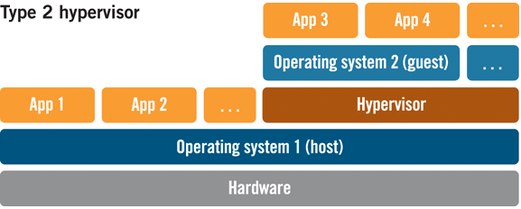
Figure 7 Component layers in a Hosted hypervisor
(“The Difference Between a ‘Type 2’ Hypervisor and a ‘Type 1’ Hypervisor,” n.d.)

Bare metal hypervisors have a distinct advantage over hosted hypervisors in that they are closer to the hardware of the hosted server. Applications within VMs using type 2 hypervisors need to go through two operating systems to get to the hardware. Bare metal hypervisors are favoured by cloud service providers because they require less CPU slices of the host hardware and therefore make more efficient use of the hardware overall.
Table 2 Mainstream hypervisor products categorised by hypervisor types
Adapted from (“The Difference Between a ‘Type 2’ Hypervisor and a ‘Type 1’ Hypervisor,” n.d.)
Type 1: Bare Metal Hypervisors | Type 2: Hosted Hypervisors
VMware ESXi  Microsoft Hyper-V  Xen | VMWare Player  Oracle VirtualBox  RedHat KVM

There are different implementations of hypervisors (for each type) as can be seen from the Table 2 above. This leads to incompatibilities between cloud service providers when application owners want to move their application from one CSP to another.

Virtualisation has also enabled scalability and the ability to build robustness in applications. A user can build one VM with the desired OS, applications and configuration and then replicate (through a type of binary copy) that “golden master” VM to create more VMs to handle the application load. An application may have 3 or more types of server configuration which would mean 3 or more golden master VMs and any one of those can be replicated depending on the scenario or part of the application that needs to scale out e.g. an application may have processing server, a database server (slave) and load balancer golden master VMs to replicate.

Hardware always fails eventually and VMs fail too, however by making copies of golden masters on the same hardware, on other hardware within a data centre and on hardware at a different geographically located datacentre then robustness can be built into an application as a whole. If one VM fails on a single hardware machine then other VMs (of same configuration) can take the slack while a new VM is created within minutes. If single hardware machine fails then copies of those VMs already exist on other hardware machines and these VMs can take the slack of the failed hardware machine while another hardware machine is configured with copies of the VMs. If an entire data centre fails e.g. a severed network connection or terrorist attack then another datacentre will have multiple hardware machines with copies of the same VMs and the application can continue to serve, maybe at a degraded level, but it continues until hardware/virtual machines have been setup/replicated again to restore the expected level of service. Cloud service providers build these tools to enable infrastructure automation and ensure that they work efficiently so that customers can have as many VMs, and other computing resources, to enable large applications to operate to the required Service Level Agreements (SLAs).

Recent innovations in the virtualisation space are trying to reduce the unit of virtualisation from an entire OS to containers that have just enough of the operating system features for the target application to operate - Linux containers (LXC) and the open source Docker project are gaining recognition in the industry with Microsoft recently announcing that they will support this technology (Foley, 2014). By reducing size, this allows the CSP to pack more virtualisation units onto a physical machine thus reducing costs and allowing them to reduce the unit cost computing power to the consumer. Amazon Web Services also recently announced AWS Lambda (Kar, 2014) which reduces the unit of virtualisation to functions – function instances are started within milliseconds on a customised event.

  - Desired State Configuration
The last few years has seen a move away from the use of golden master VMs to Desired State Configuration (DSC) tools. These allow infrastructure engineers to quickly install and configure an OS and applications onto an empty VM, through automation. When using tools like Puppet or CHEF you describe what state you want your server to be in through code as shown in Figure 8 below. These tools allow you to describe/list what applications you want installed and what configuration settings the server needs to have, then these infrastructure automations tools determine what OS commands to execute to get that server into the desired state e.g. you specify that you want an admin account on the machine with a certain password and the DSC tool will initiate the appropriate OS commands to create a user account with a name of ‘admin’ and the desired password.
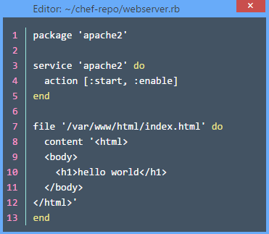
Figure 8 Simple Web Server Setup Using Chef
((Opscode, n.d.))

In Figure 8 above, when executed by a Chef client on a server VM will install the apache2 webserver software, start and enable the apache2 service and create a home page at /var/www/html/index.html with the basic content as shown.

As with golden master VMs, you can create different configurations (or recipes in Chef Terminology) for different types of servers in your overall application.

Desired State Configuration offers more flexibility and robustness over golden master VMs:
- Infrastructure is described as code and becomes easier to understand whereas your golden master VM could differ from the documented steps accompanying the VM if infrastructure engineers are not fastidious.
- Infrastructure code can and is stored in source code repositories and therefore be versioned and restored to previous versions if there is a problem with the latest version.
- DSC can offer self-healing features, where golden master VMs cannot. Chef clients on each server check that the configuration stays the same as described. If someone on the individual server changes a configuration item or application under DSC control then the chef client will determine how to bring that server back to the desired state.
- DSC can update configurations on every machine quickly. After making the necessary changes within a golden master VMs then all existing VMs that were created with the previous version need to be taken down one-by-one and replaced with a new VM styled from the updated golden master. Every Chef client communicates regularly with a Chef server to ensure that the local configuration (recipes) match what is on the server. If not, then they copy down the latest recipes (applicable to the type of server) and execute on local server to bring all servers in line with the updated desired configuration or policies.
- DSC offers a certain level platform independence, in that the same “infrastructure code” can be run on the different flavours of Linux and on Linux Containers/Docker. Chef also supports Windows, however because the operating system and application/package names are quite different the infrastructure code will not transfer directly – but concepts and tools to run the Chef Server and Clients are very similar.

- Cloud Interoperability Review
  - Introduction
Cloud Application Interoperability is the ability to move an application that contains many virtual infrastructure elements, such as servers, routers, load balancers, storage and data from one cloud service provider to another cloud service provider with little or no changes to code or configuration. This gives the cloud computing consumer purchasing power and choice of operators and rates.

The novelty behind Cloud Computing is that distributed physical resources, such as storage, CPU and networking (Infrastructure), programming frameworks and libraries (Platform) and services (Software) can now be traded as economic goods, integrated and offered on-demand through the Internet in a “pay-as-you-go” model. Cloud computing interoperability problems arise when different cloud providers try to coordinate exchange of data, applications and virtual machines. These incompatibilities can be either technical, e.g. incompatible virtualization implementations (VMware, Xen and KVM) or incompatible programming code (Java-based, PHP-based), or semantic. For instance, different cloud providers use different modelling and notation for exposing the same features (Loutas et al., 2011a)

The providers of multi-cloud frameworks range from standards bodies to universities to research arms of multi-national IT service companies. Many of the researchers in multi cloud attend the (“Future Internet Assembly (FIA),” n.d.) conference held each year in various European countries, and is supported by (“Seventh Framework Programme (FP7),” 2014). One of the tasks of this research is to evaluate the current situation of research and development into multi-clouds, this was helped by attending (Arif Mohamed, 2013). At this event a number of the multi-cloud framework providers gave an overview of their technologies, including what stage of development the frameworks are at.

  - Cloud Application Interoperability Research
In “Semantics Centric Solutions for Application and Data Portability in Cloud Computing” (Ranabahu and Sheth, 2010) proposes using Domain Specific Languages (DSL) and code generators to enable interoperability, generating artefacts (executables, configuration files, etc) for deployment on multiple IaaS and PaaS solutions. The referenced proof (Atwood, 2008) may not go far enough to prove the stated optimised shortcomings of this approach and does not address the new paradigms that have emerged in scalable computing in recent years, such as Map/Reduce, column orientated data stores etc. Also, monitoring is not addressed; monitoring is used extensively in scalable applications to identify bottlenecks or underperforming entities which could aid decisions about when to optimise the generated code. If your application is serving millions of users on thousands of servers then even small optimisations will achieve large economic benefit. Also this approach does not support mobility of components where one can move individual components to different service providers.
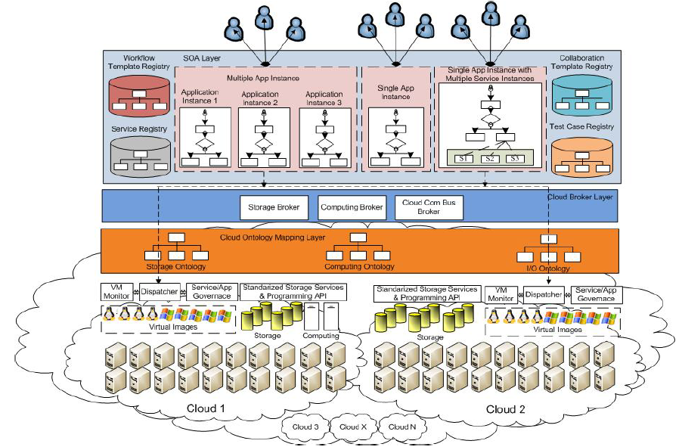
Figure 9 Service-Oriented Cloud Computing Architecture
(Tsai et al., 2010)
TODO: Need to describe this diagram in some detail [JC]
The “Service Orientated Cloud Computing Architecture” (Tsai et al., 2010) paper addresses the major concerns of enterprise organisations, such as security and multi-tenancy, automated negotiation of Service Level Agreements (SLA) and operating components of a distributed application on different cloud service providers. A service-orientated approach is engineered into the framework; many enterprise organisations already use Service Orientated Architecture patterns to decouple components of a distributed application. Ontologies are used throughout the layers of this framework and is flexible enough to cater for new types of cloud computing resources that will inevitably materialise as innovation continues to thrive in this fledging industry. Also, uniquely in this literature review, the paper proposes automated demand prediction model to enable negotiating/provisioning of resources on other cloud computing providers for expected demand in x number of days.

In “A Semantic Interoperability Framework for Cloud Platform as a Service” (Loutas et al., 2011b) attempts to eliminate the concept of IaaS as the majority of cloud computing components are now in the PaaS layer, i.e. more than one step away from the virtualised resource and this becomes the entry point for all SaaS application to computing resources. Again semantics are prevalent in this research paper.

The paper titled “Intercloud Directory and Exchange Protocol Detail Using XMPP and RDF” (Bernstein and Vij, 2010), proposes the creation of Intercloud Directories and Exchanges to facilitate interoperability. Intercloud Directories would be analogous to the Universal Description Discovery and Integration (UDDI) directories which have not enjoyed stellar success in the SOA space. Intercloud Exchanges would translate messaging to/from distributed SaaS applications – it is another possible point of failure that application architects would need to take into account to provide continuous service to their customers. This approach may prove too political to implement – who manages and defines the intercloud messaging. However, ontologies are used extensively again to facilitate the matching of components between cloud service providers.
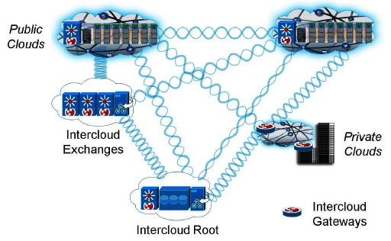
Figure 10 Reference Intercloud Topology
(Bernstein and Vij, 2010)

A review of underlying architectures contained in “Cloud computing interoperability: the state of play” (Loutas et al., 2011a) reveals common approaches in multi-cloud architectures; however it does not evaluate the maturity of those frameworks in its findings.

Table 3 Summary of multi-cloud framework types
(Loutas et al., 2011a)
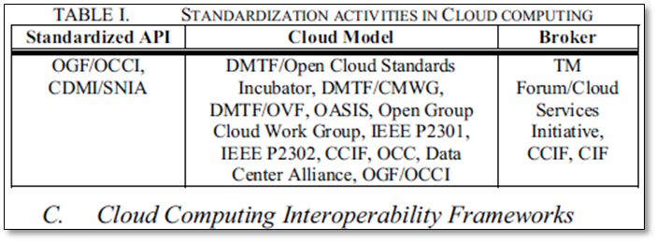

TODO: Comment by James Carswell:
Replace [I/James had moved the first paragraph of this document from here to top of doc] with a contrast to what others have researched which I should do each time I bring up other’s research.

- Design

  - Introduction

  - Reference Applications

TODO: copied and pasted from research scope & limitations – need to rewrite here!
The reference application follows a typical web application framework where some compute intensive operation (such as applying special effects to photographs on flickr.com) is required and the user interface must still remain interactive. This is achieved by using message queues to manage the compute intensive operations as efficiently as possible. As the load on the web application increases the number of web servers and (compute intensive) processors can be increased to cater for the load and maintain the interactivity of the user interface. On the client side (browser/mobile), an AJAX web page will poll the server side scripts, which in turn will use the information in the response queue (when it eventually becomes available) to retrieve the results of the compute intensive operation (such as the new image with the applied special effect).

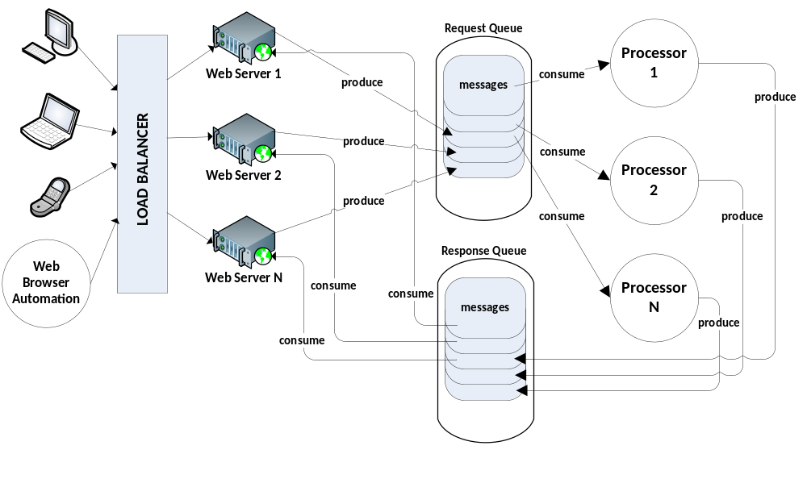
Figure 11 Design for a scalable web application

For each framework, the process described in the Figure 12 below will be followed, working on each framework separately so to keep views on a single framework independent of previously reviewed frameworks. After reviewing all nominated frameworks, a compare-and-contrast appraisal will be conducted.

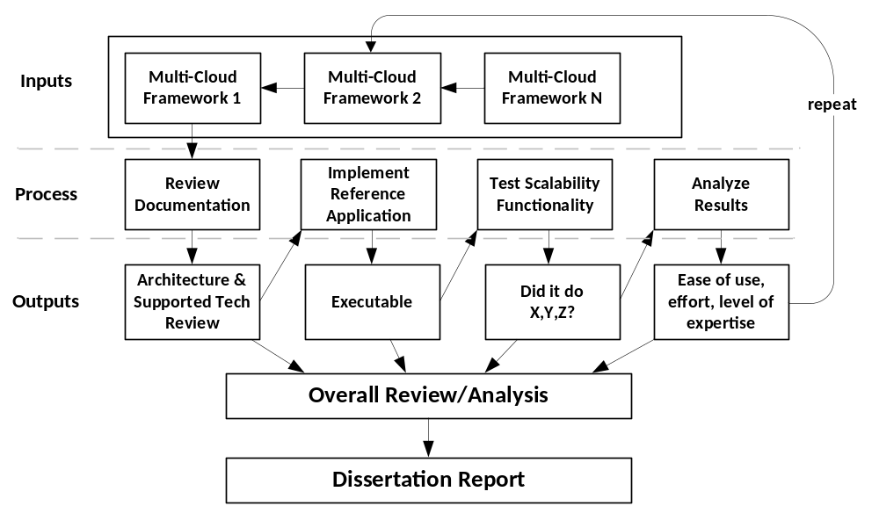
Figure 12 Experiment Process

This process will use a qualitative approach to the documentation review which will include analysing the architecture to comment on the technologies used (such as design patterns); the technologies the framework will support externally (i.e. C#, PHP, SQL Server etc.); requirements; limitations; accessibility (which cloud service providers are supported); legal issues identified/missing and the usability/readability of the documentation.

The building and testing of the reference applications brings a quantitative approach to this research. Each of the reference applications built (per framework) will be tested on a number of cloud service providers for interoperability and scalability.

A second qualitative approach will be used after the experiment stage to give an overall review of the frameworks to appraise on ease of use, expertise level required, technical requirements, reportage functionality, infrastructure items supported, service items supported and cloud service providers supported. This will also be used to give recommendations at the conclusions stages of the dissertation report.

Do any of the frameworks attempt to abstract the CLI (command line interface) so that the commands for provisioning, de-provisioning and interaction are the same across CSPs?

  - Infrastructure Considerations for the various Service Providers

  - Telemetry Measurements

  - Measurement Harness for Interoperability Frameworks

  - Source Code and Infrastructure Script Diversion Measurement

  - Choice of SCM

  - Measuring Diversion using Branching and Merging

  - Conclusion

- Implementation
  - Introduction

This chapter will …..
  - Source Code Organisation and Management

  - Integrated Development Environment

  - Reference Applications

  - Infrastructure Scripts

  - Telemetry Implementation

  - Conclusion
This chapter ….

- Experimentation & Evaluation
  - Introduction

  - Experimentation

For each framework, the process described in the Figure 12 (TODO: [JC Comment: I have this diagram earlier, in Chapter ?, I must not reproduce it again here just refer to it back in whatever chapter it is in] – done really – clean up!) previously will be followed, working on each framework separately so to keep views on a single framework independent of previously reviewed frameworks. After reviewing all nominated frameworks, a compare-and-contrast appraisal will be conducted.

This process will use a qualitative approach to the documentation review which will include analysing the architecture to comment on the technologies used (such as design patterns); the technologies the framework will support externally (i.e. C#, PHP, SQL Server etc.); requirements; limitations; accessibility (which cloud service providers are supported); legal issues identified/missing and the usability/readability of the documentation.

The building and testing of the reference applications brings a quantitative approach to this research. Each of reference applications built (per framework) will be tested on a number of cloud service providers for interoperability and scalability.

A second qualitative approach will be used after the experiment stage to give an overall review of the frameworks to appraise on ease of use, expertise level required, technical requirements, reportage functionality, infrastructure items supported, service items supported and cloud service providers supported. This will also be used to give recommendations at the conclusions stages of the dissertation report.

  - Evaluation

  - Research Question Evaluation

  - Interoperability Frameworks Evaluation

  - Existing Documentation Evaluation

  - Conclusion

    - Factors in Choosing an Interoperability Framework

    - Software Engineer/Architect Competence

    - Decision Factors to Migrate an Application/Component

- Conclusions and Future Work
  - Introduction

  - Research Definition & Research Overview

  - Contributions to the Body of Knowledge

  - Experimentation, Evaluation and Limitation

  - Future Work & Research

  - Conclusion
TODO:

Software devs/PMs should consider the use of branching features in source code management software as a means to evaluate the effort involved in migrating one or more components and use this to extrapolate the effort and costs for the entire product and/or produce line.

BIBLIOGRAPHY
A Digital Agenda for Europe, Communication from the Commission to the European Parliament, the Council, the European Economic and Social Committee and the Committee of the Regions, 2010.
Arif Mohamed, 2009. A history of cloud computing [WWW Document]. URL http://www.computerweekly.com/feature/A-history-of-cloud-computing
Arif Mohamed, 2013. FIA Dublin Workshop: Multi-Cloud Scenarios for the Future Internet [WWW Document]. URL http://www.cloud4soa.eu/fia-multicloud
Atwood, J., 2008. Hardware is Cheap, Programmers are Expensive. Coding Horror.
AWS Amazon EC2 Pricing [WWW Document], n.d. Amaz. Web Serv. Inc. URL //aws.amazon.com/ec2/pricing/ (accessed 12.17.14).
Bernstein, D., Vij, D., 2010. Intercloud Directory and Exchange Protocol Detail Using XMPP and RDF, in: 2010 6th World Congress on Services (SERVICES-1). Presented at the 2010 6th World Congress on Services (SERVICES-1), pp. 431 –438. doi:10.1109/SERVICES.2010.131
Building Ireland’s Knowledge Economy, Report to the Interdepartmental Committee on Science Technology and Innovation, 2004.
Columbus, L., 2013. Roundup of Cloud Computing Forecasts Update, 2013 [WWW Document]. Forbes. URL http://www.forbes.com/sites/louiscolumbus/2013/11/16/roundup-of-cloud-computing-forecasts-update-2013/ (accessed 12.2.13).
Foley, M.J., 2014. Docker container support coming to Microsoft’s next Windows Server release [WWW Document]. ZDNet. URL http://www.zdnet.com/article/docker-container-support-coming-to-microsofts-next-windows-server-release/ (accessed 12.22.14).
Forecast Overview: Public Cloud Services, Worldwide, 2011-2016, 2Q12 Update [WWW Document], 2012. URL https://www.gartner.com/doc/2126916/forecast-overview-public-cloud-services (accessed 12.6.14).
Future Internet Assembly (FIA) [WWW Document], n.d. URL http://www.future-internet.eu/home/future-internet-assembly.html
Gartner Identifies the Top 10 Strategic Technologies for 2012 [WWW Document], n.d. URL http://www.gartner.com/newsroom/id/1826214 (accessed 1.22.15).
Gartner’s 2014 Hype Cycle for Emerging Technologies Maps the Journey to Digital Business [WWW Document], 2014. URL http://www.gartner.com/newsroom/id/2819918 (accessed 12.5.14).
Guide to ICT-related activities in Horizon 2020 [WWW Document], 2013. . Digit. Agenda Eur. URL ec.europa.eu//digital-agenda/en/news/guide-ict-related-activities-horizon-2020 (accessed 11.22.14).
How Big Data Can Reduce Big Risk [WWW Document], 2012. . CIO. URL http://www.cio.com/article/2371591/business-intelligence/how-big-data-can-reduce-big-risk.html (accessed 12.7.14).
IBM - What is MapReduce [WWW Document], 2014. URL http://www-01.ibm.com/software/data/infosphere/hadoop/mapreduce/ (accessed 12.8.14).
IntelliGrape Software, 2013. Demystifying Auto Scaling : Evening Session on AWS CloudFront &amp; Auto ….
Kar, S., 2014. Amazon Redefining Cloud Services With AWS Lambda | CloudTimes.
Launching an Instance [WWW Document], n.d. URL http://docs.aws.amazon.com/cli/latest/userguide/cli-ec2-launch.html
Loutas, N., Kamateri, E., Bosi, F., Tarabanis, K., 2011a. Cloud Computing Interoperability: The State of Play, in: 2011 IEEE Third International Conference on Cloud Computing Technology and Science (CloudCom). Presented at the 2011 IEEE Third International Conference on Cloud Computing Technology and Science (CloudCom), pp. 752 –757. doi:10.1109/CloudCom.2011.116
Loutas, N., Kamateri, E., Tarabanis, K., 2011b. Cloud4SOA Cloud Semantic Interoperability Framework.
Mell, P., Grance, T., 2011. The NIST definition of cloud computing.
Opscode, n.d. Configure a package and service [WWW Document]. URL https://learn.chef.io/ubuntu/configure-a-package-and-service/
Ranabahu, A., Sheth, A., 2010. Semantics Centric Solutions for Application and Data Portability in Cloud Computing, in: 2010 IEEE Second International Conference on Cloud Computing Technology and Science (CloudCom). Presented at the 2010 IEEE Second International Conference on Cloud Computing Technology and Science (CloudCom), pp. 234 –241. doi:10.1109/CloudCom.2010.48
Run an Amazon EC2 Instance [WWW Document], n.d. URL http://docs.aws.amazon.com/AWSSdkDocsJava/latest/DeveloperGuide/run-instance.html
Seventh Framework Programme (FP7) [WWW Document], 2014. URL http://cordis.europa.eu/fp7/home_en.html
The Difference Between a “Type 2” Hypervisor and a “Type 1” Hypervisor [WWW Document], n.d. Virtzone - Powered Syst. URL http://www.virtzone.net/the-difference-between-a-type-2-hypervisor-and-a-type-1-hypervisor/ (accessed 12.21.14).
The Real Cloud Computing Revolution [WWW Document], 2014. . CIO. URL http://www.cio.com/article/2449646/cloud-infrastructure/the-real-cloud-computing-revolution.html (accessed 12.14.14).
Tsai, W.-T., Sun, X., Balasooriya, J., 2010. Service-Oriented Cloud Computing Architecture, in: 2010 Seventh International Conference on Information Technology: New Generations (ITNG). Presented at the 2010 Seventh International Conference on Information Technology: New Generations (ITNG), pp. 684 –689. doi:10.1109/ITNG.2010.214
Vaquero, L.M., Rodero-Merino, L., Caceres, J., Lindner, M., 2008. A Break in the Clouds: Towards a Cloud Definition. SIGCOMM Comput Commun Rev 39, 50–55. doi:10.1145/1496091.1496100
What is Apache Cassandra? [WWW Document], n.d. Planet Cassandra. URL http://planetcassandra.org/what-is-apache-cassandra/ (accessed 12.6.14).
What is Horizon 2020? [WWW Document], n.d. Horiz. 2020. URL http://ec.europa.eu/programmes/horizon2020/en/what-horizon-2020 (accessed 12.8.14).

Appendix A: Cloud Interoperability Software Development Kits

Appendix B: Source Code Management Tools

Appendix C: Telemetry Tools

TODO: [JC Comment: Put significant pieces of Java code in appendix]

